Blueprints Analyzer

# Overview

Blueprints Analyzer provides details about composite blueprints. It mainly fetches components of a blueprint and different properties related to those components.

For the time being, It fetches data related to Virtual Machine component only.

# Goal

It is prepared to ease out the process of analyzation of blueprints on daily basis. As we can get all the data in a simple, CSV format over mail.

# Solution/Logic Design

vcacCafeHost

For each blueprint

Get its name,status,Description,ID and its component “Virtual Machine”

getCompositeBlueprints(host)

Fetch component’s data like CPU,Disk,Storage,Memory,Provisional Workflow,Source Machine Label,Its Custom Properties like scriptPath,Name etc.

Write data to the file with the action “write dataToTheFile” and send the file with the mail through workflow “send mail”

end

Array.push(Blueprint,Blueprint Description,Blueprint ID,Component’s Provisioning Workflow,component’s CPU,Memory,Storage,custom Properties)

# Blueprint and component Properties

* Virtual Machine Clone From
* Source Machine label
* CPU occupied by Machine – number of CPU the component is provided with. It can have a default, minimum and maximum value.
* Memory occupied by Machine – memory the component is provided with. It can have a default, minimum and maximum value
* Storage occupied by Machine – storage provided to the component. It can have a default value, maximum value or minimum value.
* Blueprint Name
* Blueprint id
* Blueprint Status
* Blueprint Components
* Maximum Volumes occupied by disks – these are the volumes provided to the disks
* Disks occupied by Machine – No if disks the component is occupied with. It comes up with its label and capacity.
* Maximum Network Adapters occupied by Machine – network adapters the component is provided with.
* Blueprint provisioning workflow – workflow of the Blueprint
* Blueprint Customization Specification
* Blueprint Action – The mode in which the blueprint is working.
* Blueprint Type – whether it is of Server type or Desktop.
* Virtual Machine Custom Properties – virtual machine software Name and virtual machine software Script Path.

Dependencies

# Related Actions

* WriteDataToTheFile – It writes the requested data to the file.
* ValidateEmail – It validates the email address.
* regex – It replaces any newline and comma present in blueprint’s description.

# Related Workflows

* Send Mail – It attaches the file to the mail and send it to the specified requester.

# Related Configuration Elements

* fromName – Sender’s Name
* fromAddress – Sender’s Address
* vcaccafeHost – It is the host through which VRO connect with VRA to fetch the required data.
* smtpHost – with which one will be able to connect to the server to send the mail.
* CcAddress – it includes other member’s mail address to whom requester wants to send the mail.
* smtpPort -with which one will be able to connect to the server to send the mail.

# Attributes

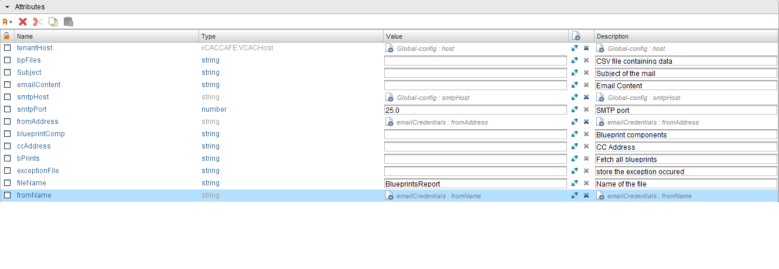

# Inputs

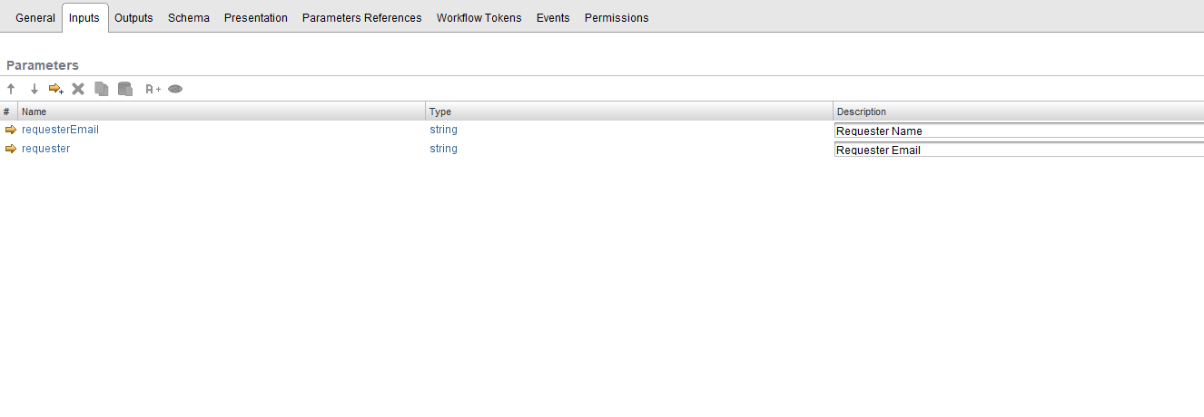

# Future Scope

It can be extended to:

* Fetch more components other than virtual machine.
* Fetch more blueprint’s or component’s properties like Reservation policy, Instances, Machine prefixes etc.